Query 1:

SELECT SRC.NAME,LEV.LVL0_ORG_HEX,LEV.LVL0_ORG_NAME,LEV.LVL1_ORG_NAME,LEV.LVL1_ORGLEAD_INTRANETID,LEV.LVL1_ORGLEAD_HEX

FROM png_mdsdb.pg_mega_pgb_application_rita_final SRC

LEFT JOIN png_mdsdb.pg_mega_pgv_app_responsible_org_person_final SRC1 ON SRC.NAME=SRC1.app_hexid AND SRC.sourceinstance=SRC1.sourceinstance

LEFT JOIN

(

Select DISTINCT a.sourceinstance,a.LVL3_ORG_HEX,a.LVL2_ORG_HEX,a.LVL1_ORG_HEX,a.LVL0_ORG_HEX,a.LVL0_ORG_NAME,a.LVL1_ORG_NAME,LVL1_ORGLEAD_INTRANETID,

LVL1_ORGLEAD_HEX

FROM png_mdsdb.pg_mega_pgv_org_itam_gbs_final a WHERE LVL0_ORG_NAME in ('Corporate Function - IT (CF-IT)','Global Business Services Organization (GBS)')

AND a.cdctype<>'D'

) LEV ON

(SRC1.responsible_org_unit_hexid=LEV.LVL3_ORG_HEX OR SRC1.responsible_org_unit_hexid=LEV.LVL2_ORG_HEX

OR SRC1.responsible_org_unit_hexid=LEV.LVL1_ORG_HEX OR SRC1.responsible_org_unit_hexid=LEV.LVL0_ORG_HEX)

AND SRC1.sourceinstance=LEV.sourceinstance

WHERE SRC1.pg_development_org='Y' AND SRC1.app_hexid IS NOT NULL AND SRC.cdctype<>'D' AND SRC1.cdctype<>'D'

AND SRC.NAME IN ('00230EB055357148','0029006D4BDB002E');

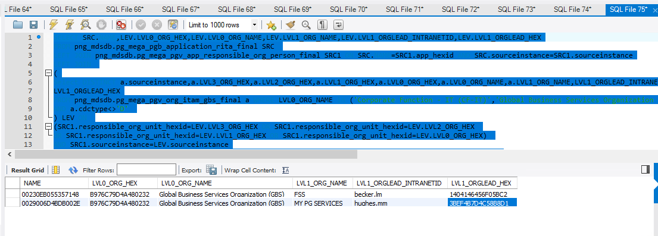

Query 2:

Select a.person_id,a.person_name,a.person_hex,a.person_email,a.person_intranet_id,a.app_hexid

from png_mdsdb.pg_mega_pgv_app_responsible_org_person_final a

where a.person_hex IN ('1404146456F05BC2','3BEF4B7D4C58B8D1');

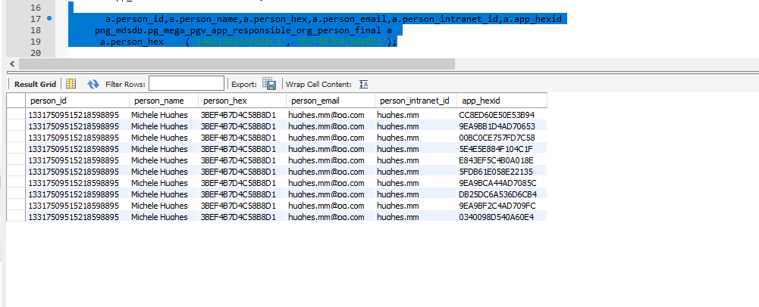

Cube :

